z



# **LAB REPORT 7**

**MAGNETIC FIELDS OF COILS**

**Date of Experiment: 1/12/2023**

**Date of Report: 8/12/2023**

**Members:**

1. Đỗ Minh Duy - ITITSB22029

2. Bùi Duy Đức – ITITIU22033

3.Ngô Tùng Chương – ITITDK22116

4.Nguyễn Minh Duy - ITITIU21186

5.Mai Văn Vinh ITITDK22117

1. What is the purpose of the experiment?

Showing the magnetic field at different points doesn't give the same result. The distance between these points in the experiment is affected by the magnetism of the inductor. Our actions don't really change the value of the study much, as we examine the field from Helmholtz coils within a certain range of the coil radius and compare it with fields from coils separated by less or more than the coil radius. Check if the magnetic field inside the solenoid follows the expected formula.

1. Briefly describe the experiment in your own words?

1. Attach a single coil to the Helmholtz Base. Connect the DC power supply directly

across the coil (not across the coil's internal resistor).

2. Pass the optics track through the coil and support the two ends of the track with the

support rods. Level the track and adjust the height so the Magnetic Field Sensor

probe will pass through the center of the coil when it is pushed along the surface of

the track.

3. Attach the Rotary Motion Sensor to the track using the bracket. Cut a piece of

thread long enough to reach from the floor to the track. Tape one end of the thread

to the side of the Magnetic Field Sensor and pass the other end of the thread over

the middle step of the Rotary Motion Sensor pulley and attach the 20-g mass. Place

the Magnetic Field Sensor in the center of the track and adjust the position of the

Rotary Motion Sensor so the thread is aligned with the middle step pulley.

4. Plug the Magnetic Field Sensor into Channel A of the ScienceWorkshop 750

interface. Plug the Rotary Motion Sensor into Channels 1 and 2. Note that the

Rotary Motion Sensor plugs can be reversed in Channels 1 and 2 to change which

direction of rotation is positive.

5. Turn on the DC power supply and adjust the voltage so about 1 Amp flows through

the coil.

6. Open the DataStudio program called "Magnetic Field of Coils.ds".

1. **Magnetic fields of a single coil** (attach the graph describing the magnetic field strength along the axis perpendicular to the coil plane and through the center of the coil in the report): Base on your graph, does the theoretical line fit the experimental data everywhere? Explain.

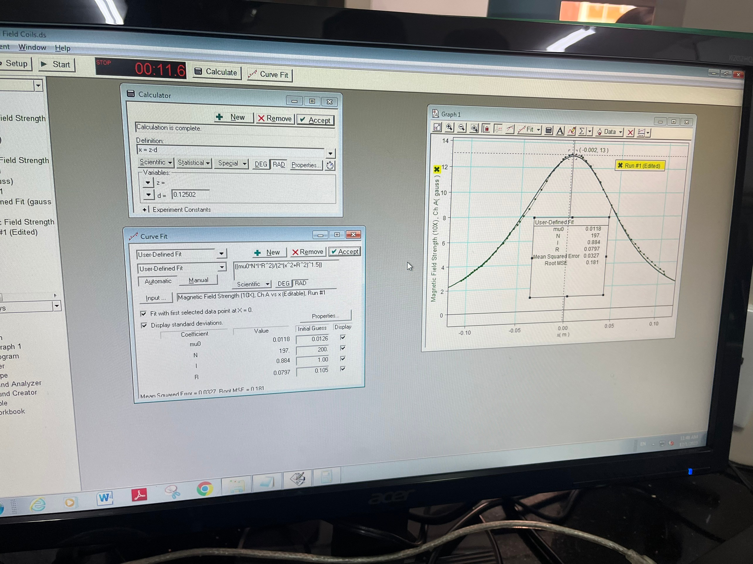

Based on the graph, we can see that the theoretical line nearly fit the experimental data everywhere, but in the end the line tend to get out of the initial one.

Reason:

First Explanation:

The reason for the difference between the observed and theoretical magnetic field lines in the experiment is that, when measuring, the magnetic field sensor doesn't align perfectly with the coil axis.

Second Explanation:

Another factor contributing to the discrepancy is the external influence on the magnetic field environment around the coil, such as electronic devices like computers and cellphones.

Third Explanation:

Additionally, the tools we use, including the magnetic field sensor, the DataStudio software, and the ScienceWorkshop, do not perform perfectly, leading to variations in the results.

1. **Magnetic fields of two coils** (attach the graph describing the magnetic field strength along the axis perpendicular to the coil planes and through the center of the coils in a case d=R in the report): Base on your graph, do the theoretical lines fit the experimental data everywhere? Explain.

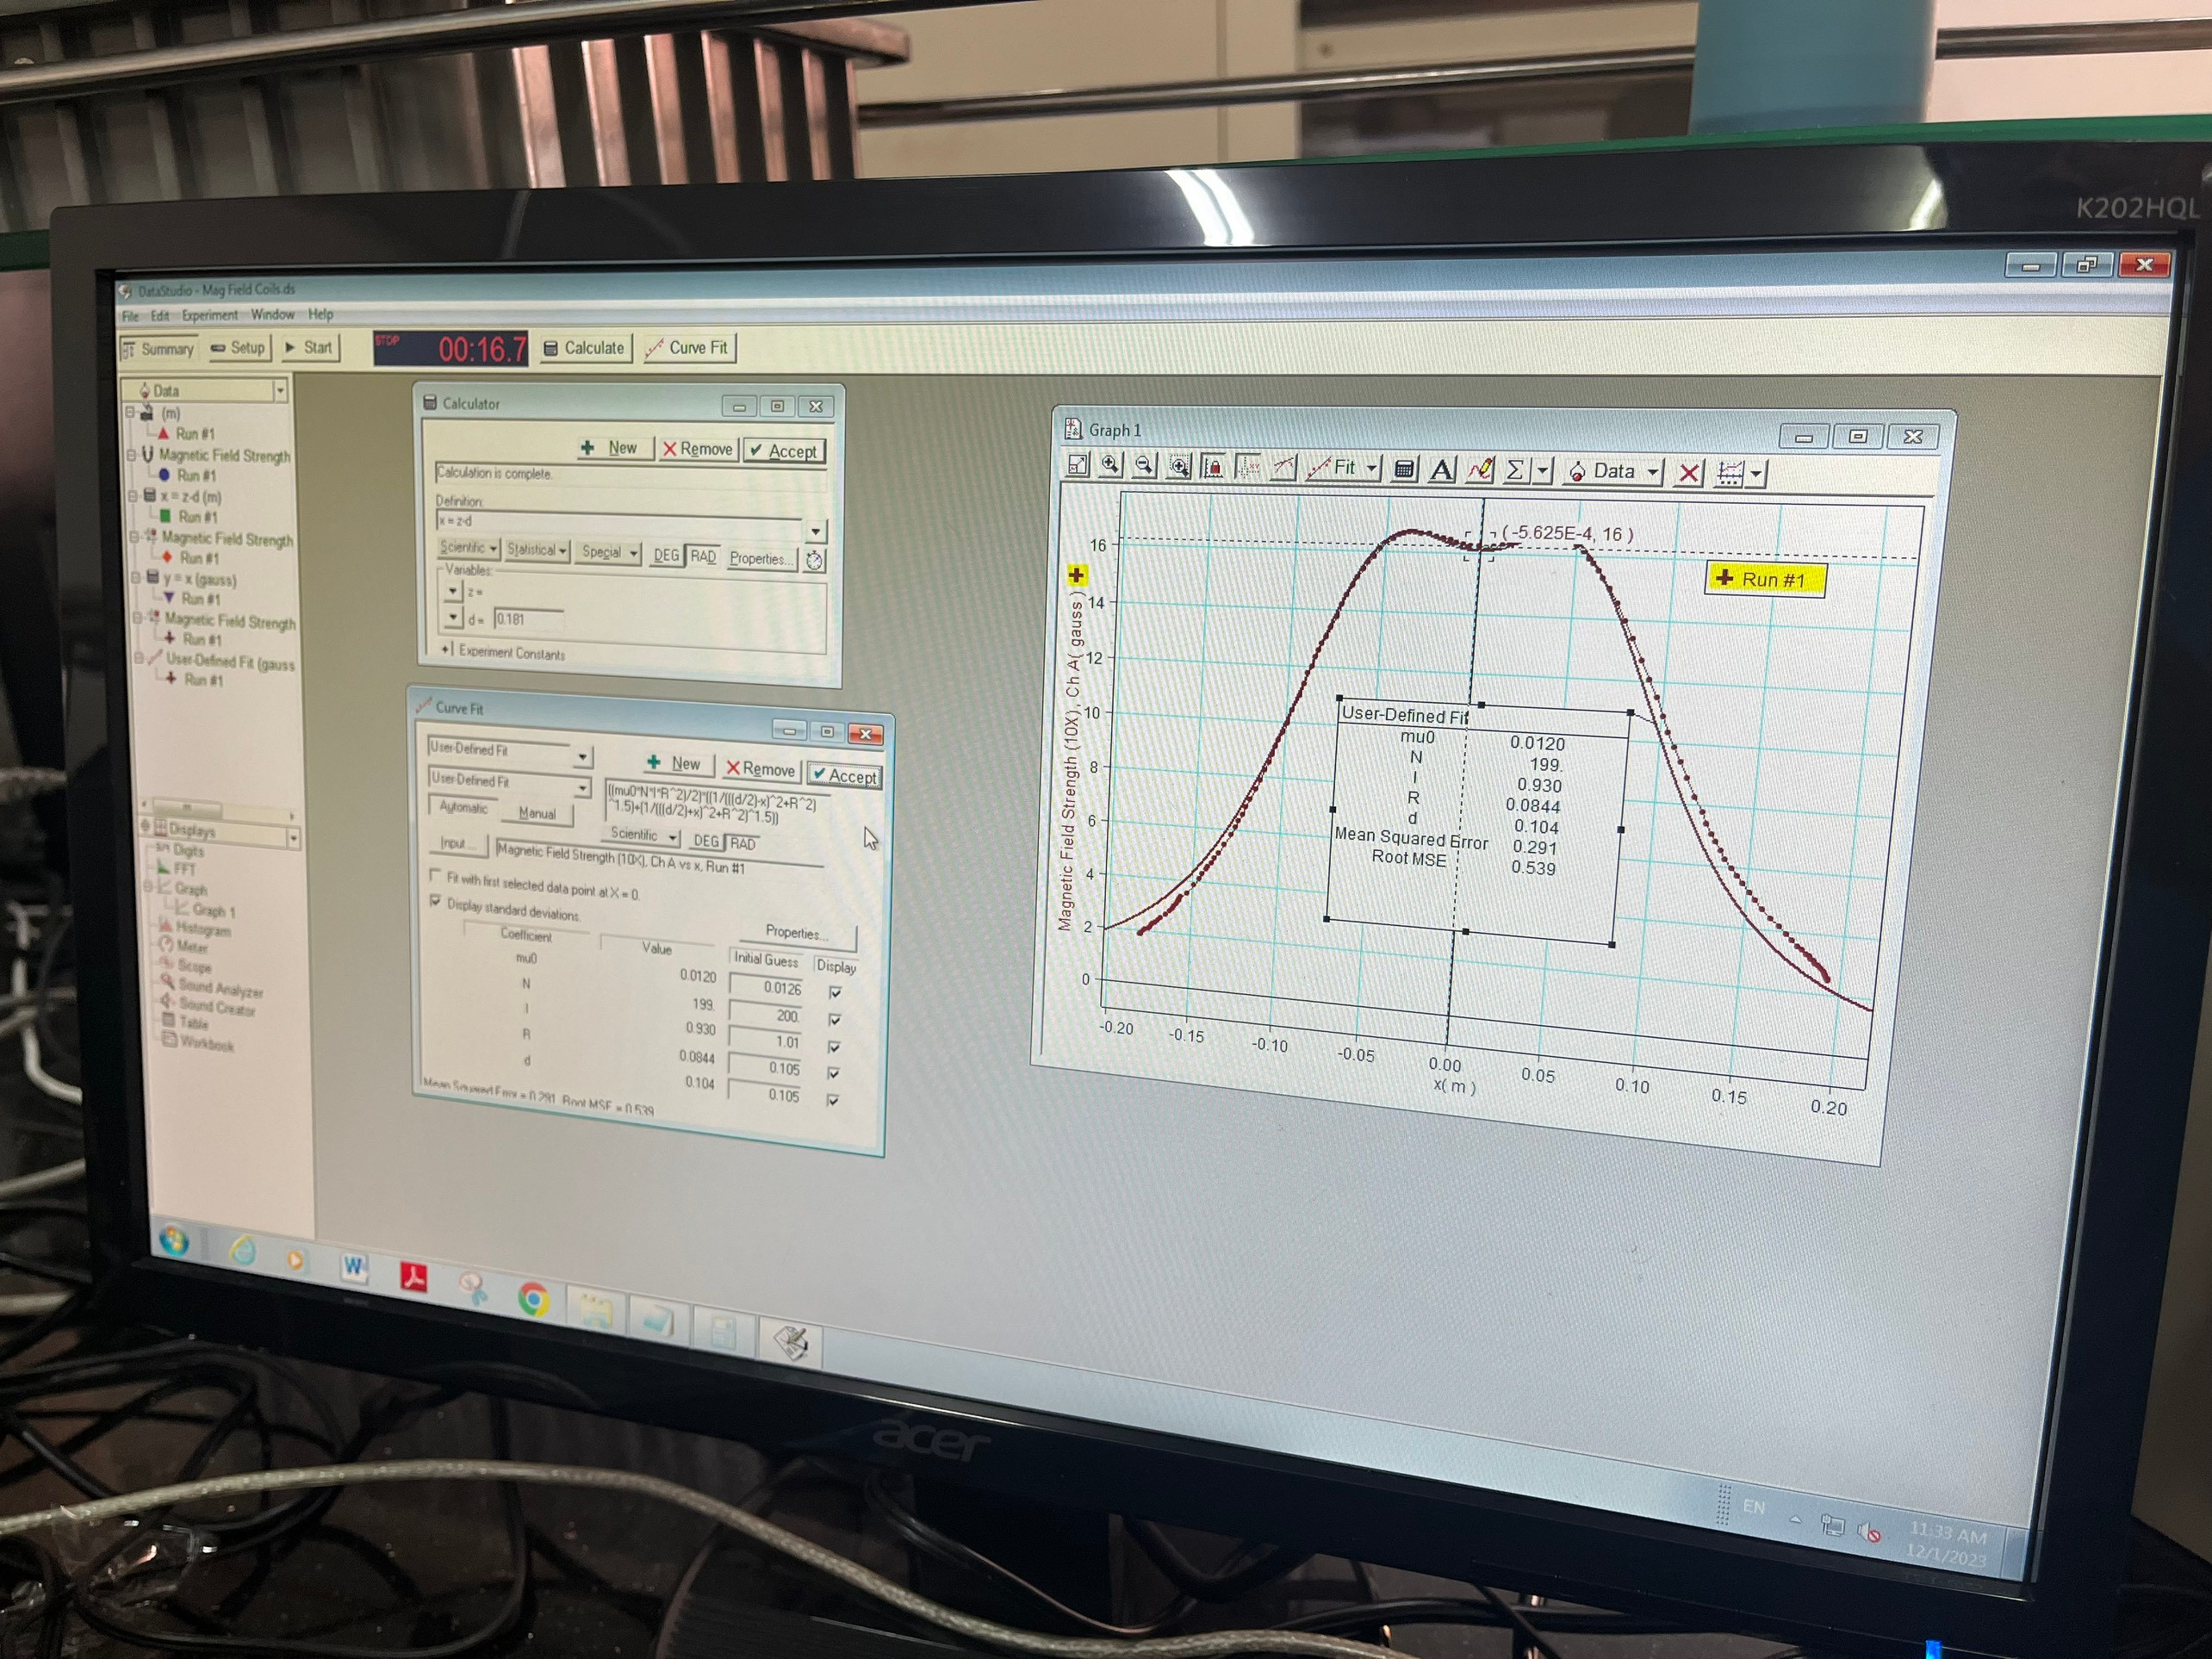

Based on the graph, we can see that the theoretical line does not fit to the experimental data, but in the overall, the line tend to bend to fit together.

The difference between them arises because, during the experiment, the distance between the two coils is not exactly half of the radius, and we add the radius value to the formula to correct the theoretical lines.

1. **Magnetic fields of a solenoid** (attach the graph describing the magnetic field strength as a function of location in the report): Calculate the magnetic field strength inside the solenoid. Compare with the value found from your experimental data.

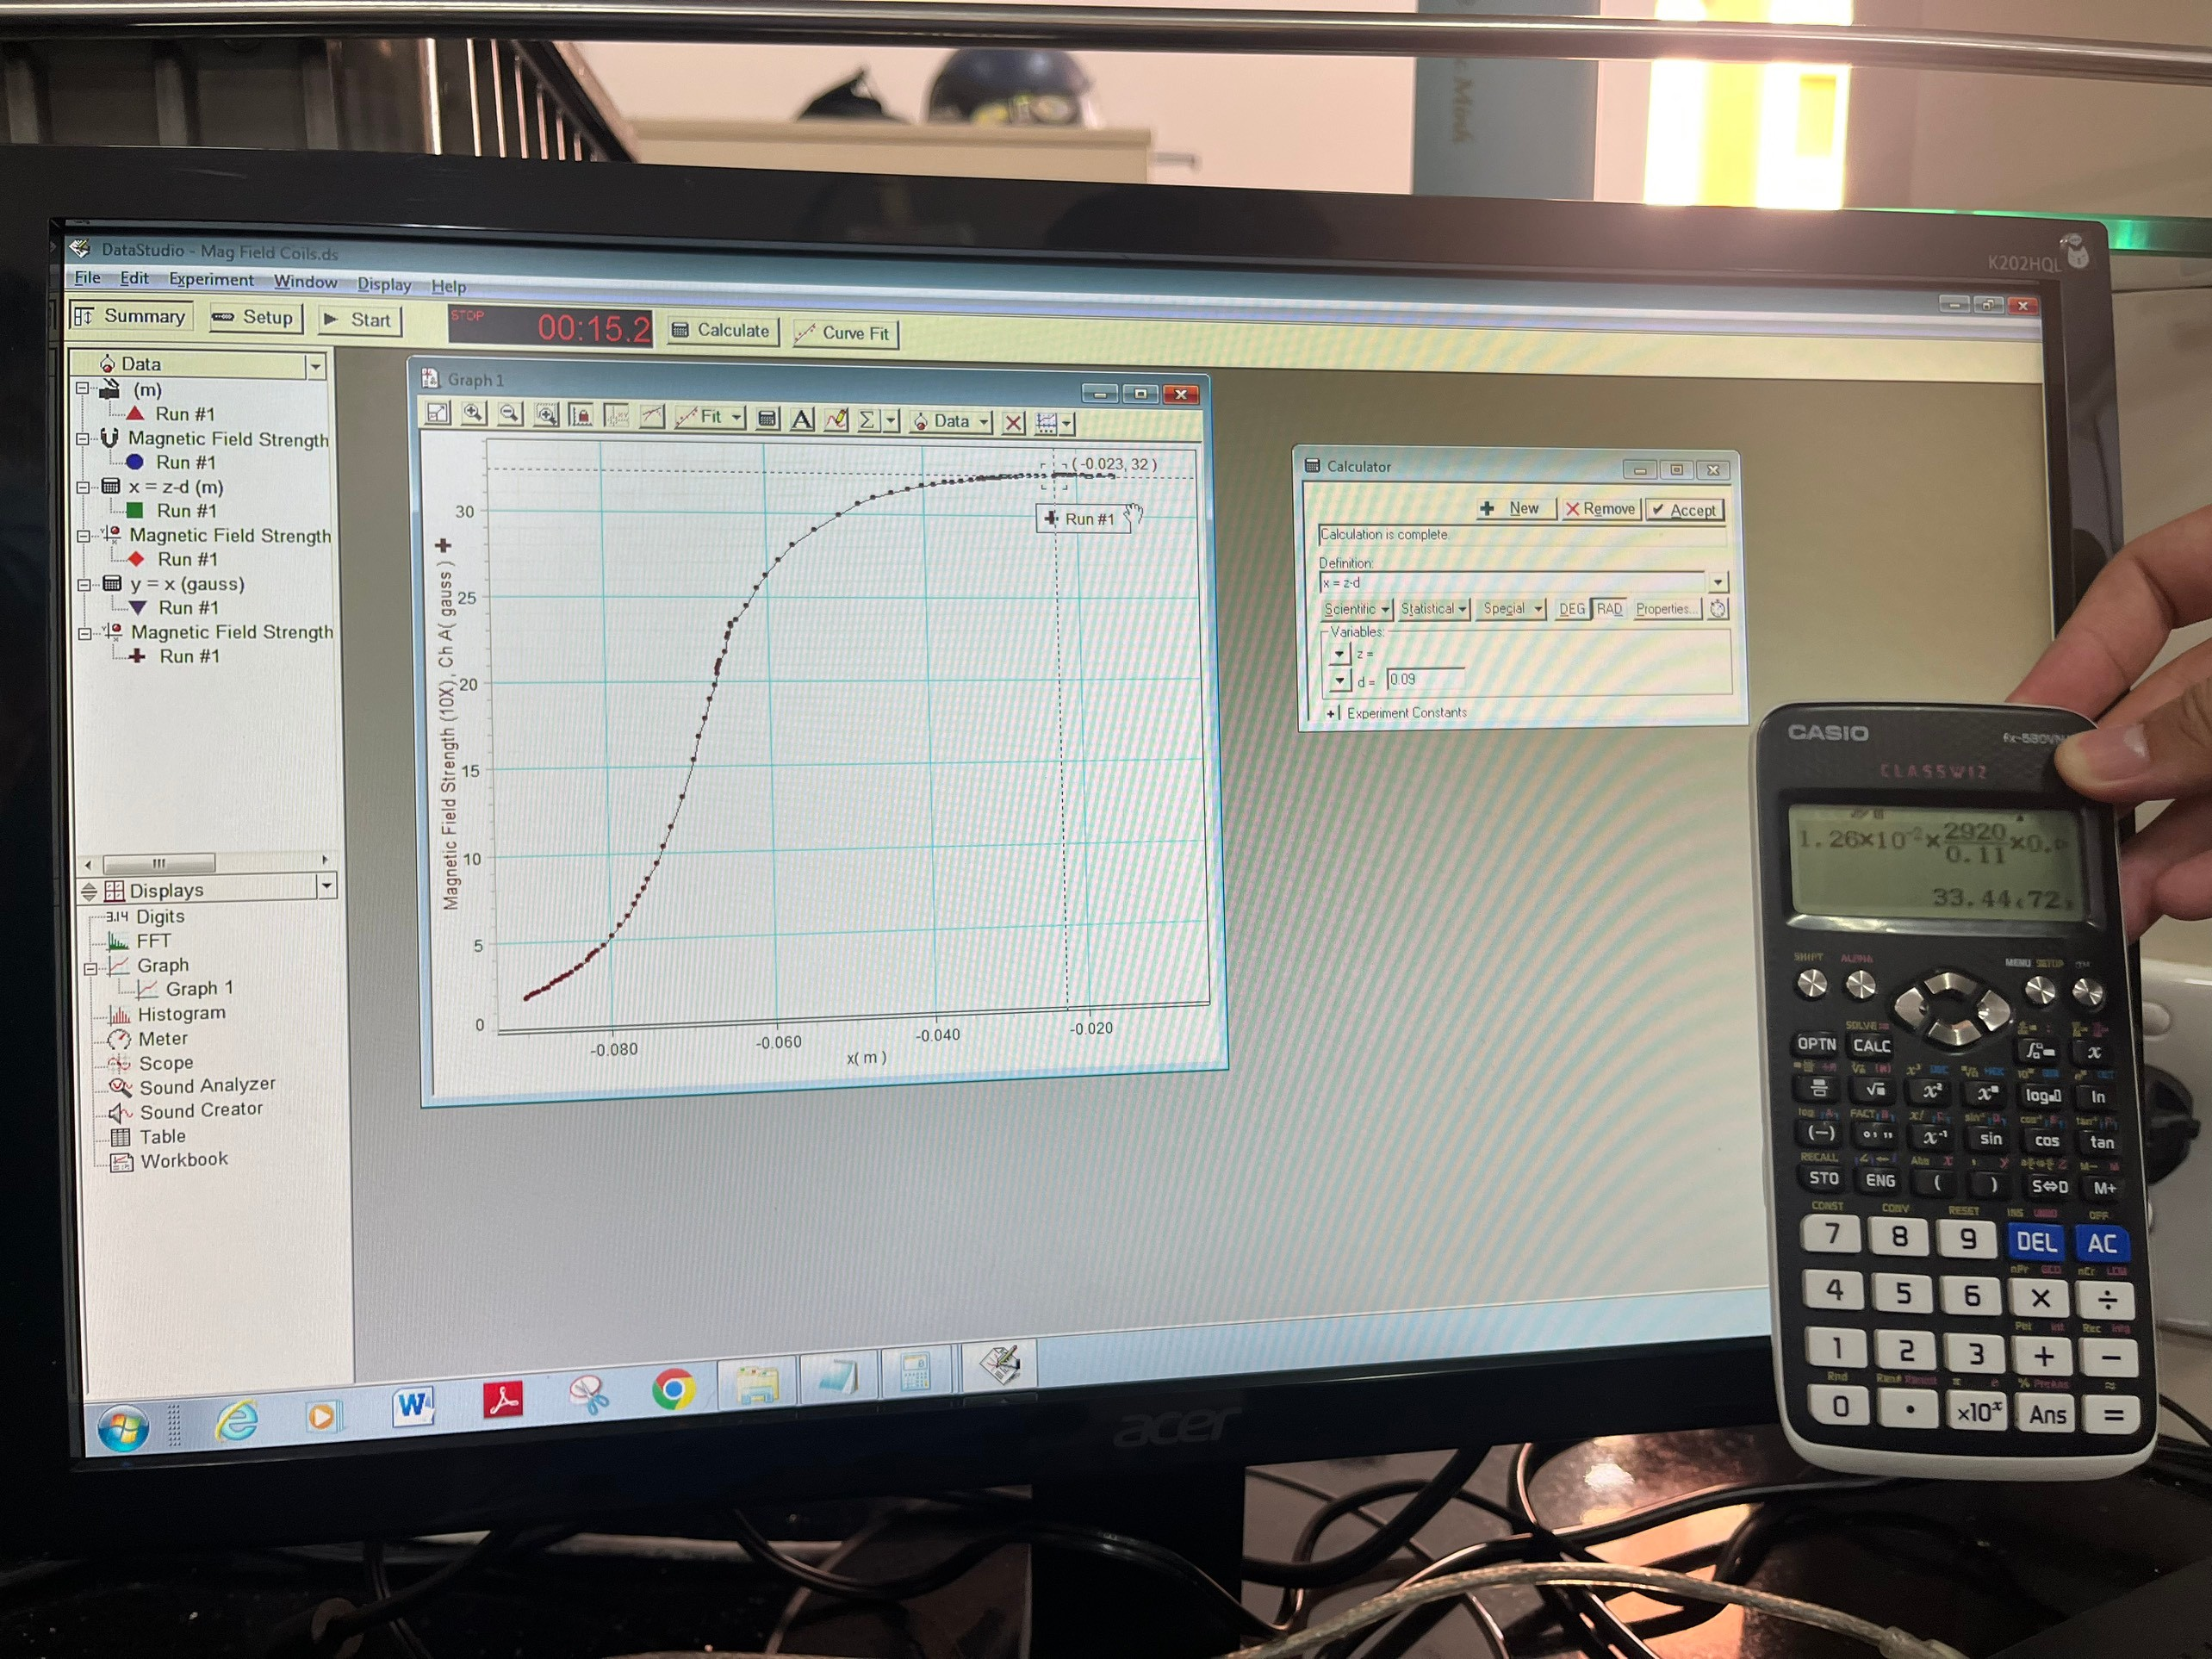

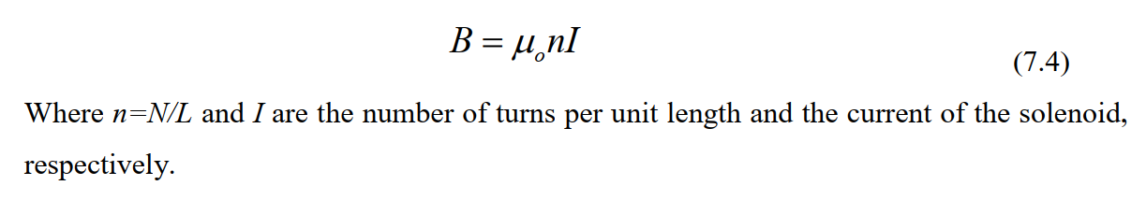

We have: B = 32 Gauss

Experiment data: 33.4 Gauss

Base on the graph, we can see that at the end of the coil, the strength of magnetic field increases and inside of the coil it remain constant.